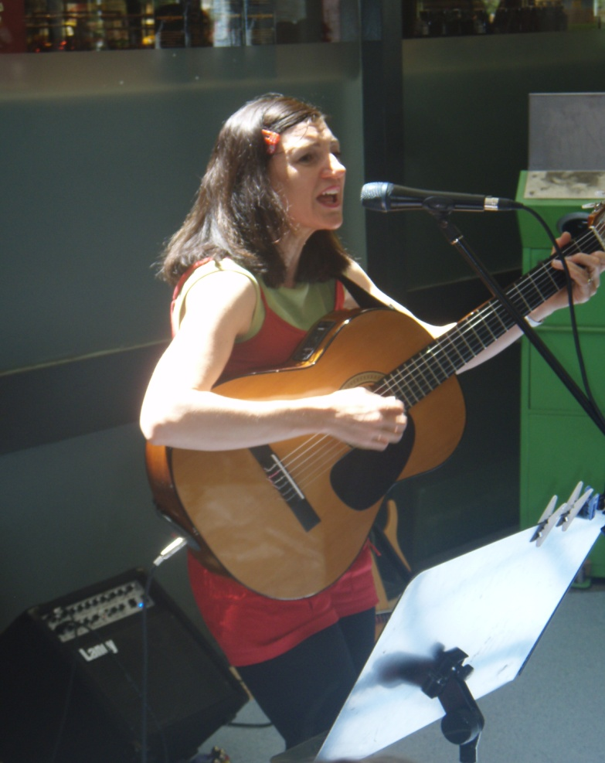
Christmas Songs with Kylie.
It is always lovely to be involved in the Community Spirit of Christmas.
There was plenty of happiness, laughter and fun to be had at Patterson Lakes shopping center as Kylie joined the team from
Princess Candy and Friends to entertain the Mums, Dads and children with Christmas songs, Puppets and Games.
Here are some snaps from the day.
For more information on booking Kylie for special occasions such as Fetes, festivals or seasonal events please email kylie@vocalenchantment.com.au

