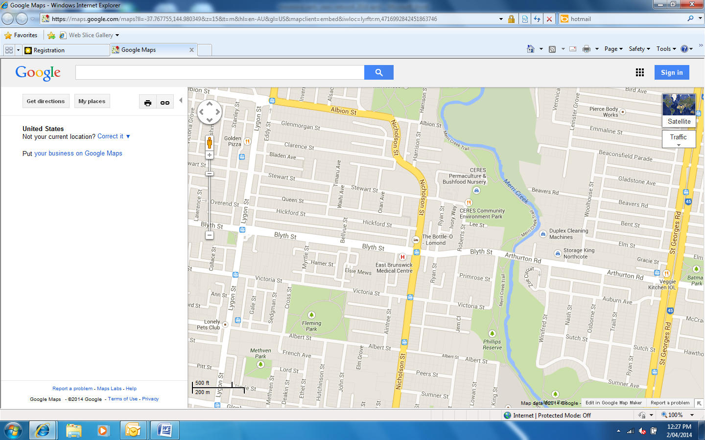



Proudly Supported by Moreland City Council

**COST**

+ $90 per person or

Early bird price before Friday 30 May: $85 per person

+ Groups of 10 - $80 per person

+ Cost includes morning tea, lunch and afternoon tea

+ **Registration and full payment due** **by Friday 27 June 2014**

Please make cheques payable to: ‘Preschool Teachers Network’

Post to: Karen Pinder,

Gowanbrae Children’s Centre

2A Marigold crescent

Gowanbrae 3043

Email: karenp@gowanbraechildrenscentre.com.au

**Location**

+ Cretan Brotherhood of Melbourne

148-150 Nicholson Street, Brunswick East

+ Workshops will be held at CERES in the afternoon:

Cr Roberts and Stewart Streets, Brunswick East

**TIME**

+ Registration 8.30 am

Start time 9.00am

**PUBLIC TRANSPORT AND PARKING**

+ Please turn over page for details

**WHO SHOULD ATTEND?**

+ All Early Childhood Professionals

+ Early year Primary School Teachers

tuesday 15 JULY 2014

CRETAN BROTHERHOOD OF MELBOURNE

and ceres enviromental park

The Early Year’s profession offers much more than care and education for children 0-8 years.

Within the realms of respectful relationships, reflective practice and rich learning environments, you play an important part in ensuring that families are supported and empowered.

As the needs of families differ, and experiences of families may be complex, it is vital that you, as a professional, are aware of external support services that exist.

‘It takes a village to raise a child.’ (George Washington Carver)

The 2014 Conference will offer you the opportunity to meet and hear Key Agencies based in Moreland and the Northern Region, and provide critical support to some of the most vulnerable children and families.

Come and join us at the Cretan Brotherhood and later in the afternoon explore

CERES Environmental Park.

connecting

with your

community

The Moreland Early Years conference 2014

**TRAM** Take the Number 96 tram to East Brunswick from the city (from Bourke St, travelling up Nicholson St) all the way to the end of the line (the intersection of Blyth and Nicholson Streets). The Cretan Brotherhood is about a 5-minute walk from the tram stop, straight down Nicolson Street, enter the building from Stewart Street.

You can also take the Number 19 tram (Sydney Road) or Number 1 tram (Nicholson Street, Holmes Street and Lygon Street) and then catch the 503 from Albion Street and get off at Stewart Street.

**BUS** Take the 503 Essendon to East Brunswick bus. Departs from Essendon Station and runs via Russell St, Napier St, Brewster St, Pascoe Vale Rd, Albion Street, Nicholson St, Stewart St.

**CAR** There is parking available at the venue, Cretan Brotherhood of Melbourne, enter from Stewart Street.

**PUBLIC TRANSPORT AND PARKING**

**Location** Melways REF, map 30 B7

Cretan Brotherhood of Melbourne

148-150 Nicholson Street, Brunswick East

Workshops will be held at CERES in

the afternoon: Cr Roberts and Stewart

Streets, Brunswick East

**Merri Community Health** Services provide many supports for the community of Moreland. We will hear from members of this Organisation outlining their programs and ways that we can ‘link in.

+ Representatives from the **Integrated Family Services** team work with children, young people and their families will join this panel.

+ Members of the **Child Health Team including Speech Therapy, Occupational Therapy and Psychology** will also join the panel.

**Gillian Barclay:**  Co coordinator Moreland Community Childcare Centres will discuss the history and implementation on Multi Age programs within their centres.

**Moreland City Council Maternal Child Health Nurse Unit** will offer insight into the extensive supports they offer families and early years services in Moreland.

**Workshops**

* **Kids Thrive:**  “Art and community development program that creates child led arts powered social change programs for all children, particularly those at risk.”
* **Vocal Enchantment:**  Kylie Cooper’s “sessions combine the Orff principles with her own style of engaging storytelling, drama, dancing and song using her principle instrument her voice.”

**Dr Denise Chapman:** Denise is a lecturer at Monash University and has served as an early childhood specialist for children with early language and literacy needs for more than a decade in both the U.S. and Australia.  She is passionate about the role of visual and digital literacies in assisting children with oral language and reading needs as well as exploring ways of using digital social stories to assist families advocating for culturally-responsive home and school-based activities for their children with special needs.

**Speakers**

The morning will begin with **Mr Andrew Day, Director Social Development Moreland City Council** facilitating an interesting discussion with members of Peak bodies who exisit to support professionals and families.

They will include:

* **Secretariat of National Aboriginal and Islander Child Care (SNAICC)** a national non government peak body in Australia representing the interests of Aboriginal and Torres Strait Islander children and families.http://legacy.snaicc.asn.au
* **Lentara UnitingCare (LUC)** was formed with the principal objective of supporting parents, carers, families and communities to reach their full potential by providing programs for people in need, offering opportunities to learn new skills and come together to reduce social isolation, and to advocate for disadvantaged people and community groups. http://www.lentarauc.org.au/
* **Foundation House** The Victorian Foundation for Survivors of Torture (VFST), or 'Foundation House' as it is also known, provides a range of services to people from refugee backgrounds who have survived torture or war related trauma. http://www.foundationhouse.org.au/about/index.htm
* **Medicare Local**, Inner North West Melbourne (INWMML) is an independent, locally governed and run, not for profit organisation dedicated to improving primary health care in our local communities. Fortunately for Moreland educators, the Access to Allied Psychological Services (ATAPS) program provides an avenue for support in the area of mental health services regarding children and their family’s wellbeing. <http://www.inwmml.org.au> l

|  |  |  |
| --- | --- | --- |
| **Name of Participant** | **Work shop**  **a or b** | **Dietary Requirements** |
|  |  |  |
|  |  |  |
|  |  |  |
|  |  |  |
|  |  |  |
|  |  |  |
|  |  |  |
|  |  |  |
|  |  |  |
|  |  |  |

**Please select one of the following workshops and list your preference in the table below:**

**A Kids Thrive:**  “Art and community development program that creates child led arts powered social change programs for all children, particularly those at risk.”

**B Vocal Enchantment:**  Kylie Cooper : “ sessions combine the Orff principles with her own style of engaging storytelling, drama, dancing and song using her principle instrument her voice.”

|  |  |
| --- | --- |
| **Name of Service** |  |
| **Address** |  |
| **Telephone** |  |
| **Email** |  |

**The Moreland Early years confrence 2014**

**Connecting with your community**

**Registration form**

Please return registration form by **By Friday 27 June**

]\

To: Karen Pinder

Email: karenp@gowanbraechildrenscentre.com.au

Post to: Karen Pinder,

Gowanbrae Children’s Centre

2A Marigold crescent

Gowanbrae 3043